Mixed Integer Problem
Ammon Wallace
USU - CEE 6410
Dr. Rosenberg
10/19/2026

Introduction
A farmer plans to develop water for irrigation. He can use a reservoir (with two alternative capacities) or pump from a lower river diversion. The capital costs are $10,000/year and $6,000/year for the high and low-capacity reservoirs. The pump cost is $8,000/year with an operating cost of $20/ac-ft. The farmer needs to decide which option provides maximum profit. This paper will provide the problem formulation, solution and analysis.
Problem Formulation
The dimensions of the problem are the location of water (Res., River, Pump, and Farm) and the time of season (1 or 2).
The decision variables are
- How many acres to plant, A [acres]
- How much water to divert to each location per season; X(loc,t) [ac-ft].
- Which reservoir alterative and/or pump site to choose as the source; $I\left(source\right),$[binary].
The objective function is
- Maximizing profit; $Max\left(Z\right)=300*A-C\left(source\right)*I\left(source\right)-X\left(pump,t\right)*20$ [$]
The constraints are
- Mass balance at reservoir; $X(res, t) = X(res, t-1) + Inflow(t) - X(farm, t) - X(river,t)$,
  - For the initial loop X(res, t-1) = 0, because the initial storage of the reservoir is 0 ac-ft. This equation applies to each season.
- Mass balance at pump station for each season; $X\left(pump,t\right)≤ X(river, t) + 2*(182.5)$
  - The equation is less than or equal to because the farmer is not required to use all the water in the river. This equation applies to each season.
- Dam capacity; X(res, t) $≤$ I(high)*Capacity(high) + I(low)*Capacity(low), [ac-ft]
- Pump capacity; X(pump, t) $≤$ 182.5*Capacity(pump)*I(pump), [ac-ft]
- Dams being mutually exclusive; I(high) + I(low) $≤$ 1
- Irrigation demand; X(farm, t) + X(pump,t) = A*demand(t), [ac-ft]
Solution
Planting 382.5 acres will produce $82150.00 of profit for the year. This profit is based on following the water schedule provided in Appendix A.
Analysis
The mixed integer problem results provide insights into management strategies. Building both a pump and dam with high capacity is the best option because it provides the most water, which allows for the most acres planted. This model assumes there is unlimited land for agriculture growth and that the river does not have a minimum flow requirement. Groundwater and river inflows may fluctuate throughout the year and change the available water for the reservoir and river.
Conclusion
Maximizing the available water is the best way to make the most profit for this problem. By building a high-capacity dam and pump station, and developing 382.5 acres of agricultural land, the farmer could profit $82150.00 each year.
Appendix A – Water Schedule

Table 1: Water Schedule (Wallace, 2026)
 | Season 1 | Season 2
Reservoir Storage (ac-ft) | 582.5 | 0
Farm Diversion (ac-ft) | 17.5 | 782.5
Pump Diversion (ac-ft) | 365 | 365

Appendix B – Problem Statement
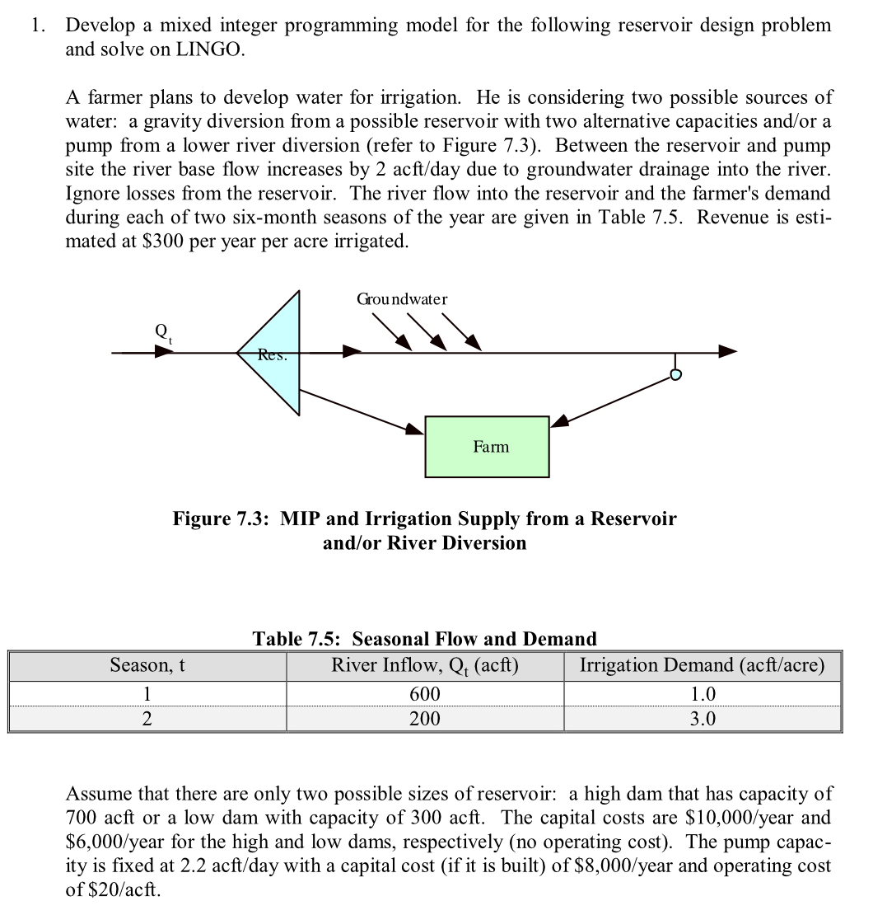
Figure 1: Mixed Integer Problem (Bishop, 1999)

Appendix C – Sources
Bishop, A Bruce; Hughes, Trevor; and McKee, Mac, "Water Resources Systems Analysis - Course Notes" (1999). All ECSTATIC Materials. Paper 76. https://digitalcommons.usu.edu/ecstatic_all/76
Wallace, A. (2026). Aggienommaste/CEE-6410: Repo for all CEE 6410 assignments. taught by Dr. Rosenberg at USU. GitHub. https://github.com/AggieNommaste/CEE-6410.git

AI Statement
I used AI (Gemini) to proofread my report and help fix some grammatical errors. This is in line with the USU AI policy because the AI tool was not used to write my report or create new ideas. It was used to aid me in making sure my report was consistent and grammatically accurate.
https://share.gemini.google/SJouDIrns5oC

Category  (Max. Score) | No Evidence | Doesn’t Meet Standard | Nearly Meets Standard | Meets Standard | Exceeds Standard | Self- Score | Instructor Score
Title  (1) | Absent  0 | Evidence of two or less  0 | Evidence of three  0 | Evidence of four  1 | Title – can assess main point from title alone; Name, Instructors’ Names, Course, Date, Neatly finished 1 | 1
Introduction  (3) | Absent, no evidence  0 | There is no clear introduction or main topic.  1 | Introduction states the main topic but either:  - Does not give a full overview, Or:  - Too detailed, leading to annoying repetition later. 2 | The introduction states the main topic and previews the structure of the report.  2 | The introduction states the main topic and previews the structure of the report. Good overview of the problem and solution approach. Gives enough detail to motivate the reader to continue reading.  3 | 2
Organization and structural development of the idea: procedure, results, conclusions  (10) | No content provided.  0 | Paragraphs fail to develop the main idea. No section headers or guide to help the reader understand how material is organized.  1 – 5 | Organization of ideas not fully developed. Paragraphs lack supporting detail sentences. No transitions and/or ineffective section headers.  6 - 7 | Paragraph development present but not perfected. Each paragraph has sufficient supporting detail sentences. Few transitions.  8 | Writer demonstrates logic and sequencing of ideas through well-developed section headers, paragraphs, and transitions. The first sentence of each paragraph is the summary sentence.  9 - 10 | 8
Technical Correctness  (70) | Questions not addressed.  3 – 42% | The writer has no clue what they are talking about.  45 – 58% | Sketchy: left out required design points. Did not work on this as much as you should have, and it shows. Many important answers are incorrect.  61 – 79% | Discussion lacks adequate detail, but all the necessary points are covered and nearly all answers are correct.  82 – 88% | Provides what was explicitly asked for. The function of each piece is demonstrated to the reader in adequate, but not overwhelming, detail. Answers are correct and reasonable.  91 – 100%
Technical Correctness  (70) | 1) Problem Formulation - Dimensions, Decision Variables (10 pts), Objective Function (10 pts), Constraints (10 pts) |  |  |  |  | 30
Technical Correctness  (70) | b) Solution Method (20) |  |  |  |  | 15
Technical Correctness  (70) | c) Results, Recommendations, and New Insights for Management (20) |  |  |  |  | 15

Category  (Max. Score) | No Evidence | Doesn’t Meet Standard | Nearly Meets Standard | Meets Standard | Exceeds Standard | Self- Score | Instructor Score
Word Usage and Format  (7) | Not applicable | Numerous and distracting errors in punctuation, capitalization, spelling, sentence structure, word usage, significant figures, tables, and figures. Data vomited onto page(s). Unacceptable / unprofessional at the graduate level. 1 – 5 | Misspelled words, poor English grammar and word choice. Main body of report is either longer or significantly less than one page. Figures are too small and/or under-labeled, although they are usually of acceptable quality and focus. Tables incoherent or not cohesive. Bad font sizes. Too much or too little data in appendices. Could be improved by being more meticulous.  5 | Almost no errors in punctuation, capitalization, spelling, sentence structure, word usage, significant figures, and presentation of figures, tables, and appendices. Main body of report is one page or less  6 | Punctuation, capitalization, spelling, sentence structure, word usage, and significant figures all correct. Main body of report is one page or less. Clear, consistent fonts. Good word processing skills. Figures have adequate contrast. Informative figure and table titles and legends. Figures have appropriate axis tick spacing, labels, units, and legends. Table columns cohesive, labeled, and specify units. Document is stapled. Appendices, if provided, are separated by topic, and each have a title, discussion, and proper formatting and display of information 7 | 7
Conclusion  (4) | Absent  0 | Incomplete and/or not focused. 1 | The conclusion does not adequately restate the main results. 2 | The conclusion restates the main results. 3 | The conclusion restates the main results, and is an effective summary. 4 | 4
Use of AI  (3) | Absent  (Return without grade) |  |  | See Policy on Use in Syllabus  If used, list the AI tool], provide a short description of use, how use is within the course policy, and link to the transcript of student-AI interactions.  If not used, write “No AI was used in the analysis or write-up of this report.” 3 |  | 3
References  (2) | Absent  0 | Numerous errors, off-the-wall sources used. 0 | Some errors in citing format; more sources should be cited. 1 | Prior work cited with few errors.  2 | All prior work and data sources are cited in the correct format with no errors. 2 | 2
TOTAL (100) |  |  |  |  |  | 87

